 

INTELLIGENT SAFETY SYSTEM FOR WOMEN SECURITY USING ATMEGA328

MICROCONTROLLER

# A PROJECT REPORT

*Submitted by*

**S.KEERTHIKA**

**S. KIRUTHIKA**

**M.KOWSALYA**

**S.PANDI DEVI**

*In partial fulfillment for the award of the degree of*

**BACHELOR OF ENGINEERING**

*in*

ELECTRONICS AND COMMUNICATION ENGINEERING

# SSM INSTITUTE OF ENGINEERING AND TECHNOLOGY DINDIGUL-624002

**ANNA UNIVERSITY: CHENNAI-600025**

JUNE 2022

BONAFIDE CERTIFICATE

Certified that this project report “**Intelligent safety system for women security using ATMEGA328 microcontroller”** is the bonafide work of “**S.KEERTHIKA (922119106040),S.KIRUTHIKA(922119106043),M.KOWSALYA**

**(922119106046),S.PANDI DEVI(922119106070)”** who carried out the project work under my supervision.

# SIGNATURE OF HOD SUPERVISOR

**Dr. S. KARTHIGAI LAKSHMI, K. DIVYA**

**HEAD OF THE DEPARTMENT PROFESSOR**

Department of Electronics and Department of Electronics and

Communication Engineering, Communication Engineering,

SSM Institute of Engineering SSM Institute of Engineering

And Technology, And Technology,

Dindigul - 624002. Dindigul - 624002. Submitted for the VIVA-VOCE Examination held on

# INTERNAL EXAMINER EXTERNAL EXAMINER

**ACKNOWLEDGEMENT**

First and foremost, we would like to express our deep sense of gratitude to our most honorable Chairman and Management Trustee **Mr.K.Shanmugavel** of SSM Institute of Engineering and Technology for providing us with necessary facilities during the course of study.

We feel immensely pleased to express our sincere thanks to our Principal

**Dr.D.Senthil Kumaran** for encouragement and support.

We extend our solemn gratitude to **Dr.S.Karthigai Lakshmi**, Head of the Department, Electronics and Communication Engineering, for his timely support to all our activities. We express our sincere thanks to our guide **K.DIVYA Professor/ECE** for his guidance throughout our project work.

Also we express our thanks to the Faculty members of our Department, nonteaching staff members and my dear friends for their moral support, help and encouragement towards the successful completion of the project. We are most indebted to our parents, with whose support, resulted in making our dreams of becoming successful graduates, a reality.

**TABLE OF CONTENTS**

|  |  |  |  |  |  |
| --- | --- | --- | --- | --- | --- |
| **CHAPTER NO** |  |  | **TITLE**  **ABSTRACT**  **LIST OF TABLES**  **LIST OF FIGURES**  **LIST OF ABBREVIATION** | | **PAGE NO** |
| **1**  **2**  **3**  **4**  **5**  **6** | 1.2  3.1  3.2  4.1  4.2  5.1  5.2  5.3  5.4  5.5  5.6  5.7  5.8  6.1  6.2  6.3 | 1.2.1  1.2.2  1.2.3  1.2.4  1.2.5  1.2.6  1.2.7  3.1.1  3.2.1  3.2.2  4.1.1  4.1.2  4.1.3  4.1.4  4.2.1  4.2.2  4.2.3  4.2.4  4.2.5  4.2.6  4.2.7  4.2.8  5.1.1  5.1.2  5.1.3  5.1.4  5.1.1  5.1.2  5.1.3  5.1.4  5.1.5  5.3.1  5.3.2  5.3.3  5.3.4  5.3.5  5.5.1  5.6.1 | **INTRODUCTION**  EMBEDDED SYSTEM  EMBEDDED SYSTEM CLASSIFICATION  EMBEDDED SYSTEM HARWARE  EMBEDDED SYSTEM SOFTWARE  REAL TIME OPERATING SYSTEM  MEMORY AND PROCESSORS  EMBEDDED SYSTEM CHARACTERSTICS  EMBEDDED SYSTEM APPLICATION  **LITERATURE SURVEY**  EXISTING SYSTEM  DISADVANTAGE  PROPOSED SYSTEM  ADVANTAGE  BLOCK DIAGRAM  **SOFTWARE DETAILS**  ARDUINO IDE  LIBRARIES  CONNECTING THE ARDUINO  PREPARING THE BOARD  LOADING CODE  PROTEUS  ABOUT PROTEUS  FEATURES  HISTORY  PROUCT MODULES  SCHEMATIC CAPTURE  MICROCONTROLLER SIMULATION  PCB DESIGN  3D VERIFICATION  **HARDWARE REQUIREMENTS**  ARDUINO UNO  SPECIFICATION  COMMUNICATION  PINS GENERAL PINS FUNCTION  SPECIAL PIN FUNCTION  POWER SUPPLY CIRCUIT  LINEAR POWER SUPPLY  TRANSFORMER  BRIDGE RECTIFIER  SMOOTHENING  REGULATOR  GLOBAL POSITIONING SYSTEM  WORKING OF GLOBAL POSITIONING SYSTEM  RADIO FREQUENCY  MONITORING SOFTWARE  KEY CONSIDERATION  EVALUATION AND TESTING  LIQUID CRYSTAL DISPLAY  PUSH BUTTON  APPLICATION  NODE MCU  FEATURES  BUZZER  NERVE SIMULATOR  **CONCLUSION AND REFERENCE**  CONCLUSION  FEATURE ENHANCEMENT  REFERENCE | |  |
|  |
| **FIGURE NO.**  1.2.1  1.2.2  1.2.3  3.2.1    4.1.1  4.2.1  5.1.1  5.2.1  5.2.2  5.2.3  5.2.4  5.2.5  5.3.1  5.4.1  5.4.2  5.5.1  5.6.1  5.7.1  5.8.1 | **DESCRIPTION OF FIGURE**  **LIST OF FIGURES**  Embedded System Circuits  Embedded System Classification  Embedded System Characteristics  Block Diagram of Proposal System    The Arduino IDE  Simulation of Proteus  Arduino UNO  Transformer  Bridge Rectifier  Smoothing  Power Supply Circuit  Power Supply Circuit  GPS  LCD Display Unit  Internal Working of LCD Unit  Push Button  Node MCU  Buzzer  Nerve Simulator | | | **PAGE NO** | | |

**LIST OF ABBREVATION**

|  |  |
| --- | --- |
| **WHO**  **RTOS**  **DSP**  **RISC**  **ASSP**  **ARM**  **RAM**  **SOC**  **EEPROM**  **PROM**  **ROM**  **IOT**  **RFID**  **BLE**  **UV**  **GSM**  **LCD**  **IDE**  **LED**  **ADK**  **FTDI**  **AVR**  **PCB**  **ISIS**  **DOS**  **SPICE**  **MCAD**  **CAD**  **SRAM**  **UART**  **PWM**  **SPI**  **MOSI**  **SCK**  **SPI**  **SDA**  **SCL**  **AREF**  **PSU**  **GPS**  **CRT**  **MCU** | World Health Organization  Real Time Operating System  Digital Signal Processing  Reduced Instruction Set Computer  Application-Specific Standard Product  Advanced RISC Machine  Random Access Memory.  Security Operations Center  Electrically Erasable Programmable Read-Only Memory  Programmable Read-Only Memory  Read-Only Memory    Internet of Things    Radio Frequency Identification  Base Level Engineering    Ultraviolet    Global System For Mobile Communication  Liquid-Crystal Display  Integrated Development Environment  Light-Emitting Diode  Application Development Kit    Future Technology Devices International Limited,    Automatic Voltage Regulator  Printed Circuit Board  Intermediate System To Intermediate System  Disk Operating System,  Simulation Program with Integrated Circuit Emphasis  Mechanical Computer-Aided Design    Computer-Aided Design    Static Random Access Memory    Universal Asynchronous Receiver-Transmitter    Pulse Width Modulation  Serial Peripheral Interface  Master Out Slave In    Serial Clock  Serial Peripheral Interface  Serial Data Pin    Serial Clock Pin  Analog Reference  Power Supply Unit  Global Positioning System  Cathode-Ray Tube  Microcontroller Unit |

**ABSTRACT**

The world is becoming unsafe for women in all aspects. The crime against women are increasing at a higher rate. The employed women are feeling unsafe due to increasing crimes. According to the reports of WHO, NCRB-social-government organization 35% Women all over the world are facing a lot of unethical physical harassment in public places such as railway-bus stands, foot paths etc. The security of women is the most important concern these days and to build a safety device to act as a rescue and to prevent from harm at the time of hazard is highly necessary especially for women. Thus this project proposes the intelligent safety system for women to provide the safety measure in public places as well as travelling alone through public transports (school buses, company vehicle etc.). This project proposed a new model for the women security in public places which aims to provide the safety environment. This is a security system that is designed to providing security to women so that they never feel helpless while facing such critical situations.

**CHAPTER 1**

**INTRODUCTION**

In modern India, women continue to face social challenges and are often victims of abuse and violent crimes and, according to a global poll conducted by Thomson Reuters, India is the ”fourth most dangerous country” in the world among the G20 countries. This project focuses on the security system that is designed solely to serve the purpose of providing safety and security to women so as they never feel helpless while facing such social challenges.

A security solution that creates a sense of safety among women needs to be developed. In instances of attack, it is largely reported that women’s are immobilized. Therefore there is a need of a simpler safety solution that can be activated as simply as by pressing a switch and can instantly send alerts to the near ones of the victim. This project focuses on a security system that is designed uniquely to serve the purpose of providing security and safety to women. The objective of research work is to create a portable safety device for women, which provides following facilities 1. Alerts family and friends by sending emergency message 2. Captures the images/video of the attacker to maintain a proof for legal actions.

**1.2 EMBEDDED SYSTEM**

An embedded system is one kind of a computer system mainly designed to perform several tasks like to access, process, store and also control the data in various electronics-based systems. [Embedded systems](https://www.elprocus.com/mini-embedded-systems-projects-ideas/) are a combination of hardware and software where software is usually known as firmware that is embedded into the hardware. One of its most important characteristics of these systems is, it gives the o/p within the time limits. Embedded systems support to make the work more perfect and convenient. So, we frequently use embedded systems in simple and complex devices too. The applications of embedded systems mainly involve in our real life for several devices like microwave, calculators, TV remote control, home security and neighborhood traffic control systems, etc.

An embedded system is integration of hardware and software, the software used in the embedded system is set of instructions which are termed as a program. The microprocessors or microcontrollers used in the hardware circuits of embedded systems are programmed to perform specific tasks by following the set of instructions. These programs are primarily written using any programming software like Proteus or Lab-view using any programming languages such as C or C++ or embedded C. Then, the program is dumped into the microprocessors or microcontrollers that are used in the [embedded system circuits](https://www.elprocus.com/real-time-applications-of-embedded-systems/).

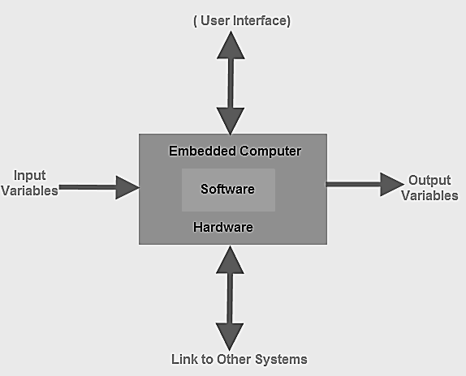

**FIG 1.2.1 EMBEDDED SYSTEM CIRCUITS**

### **Embedded System Classification**

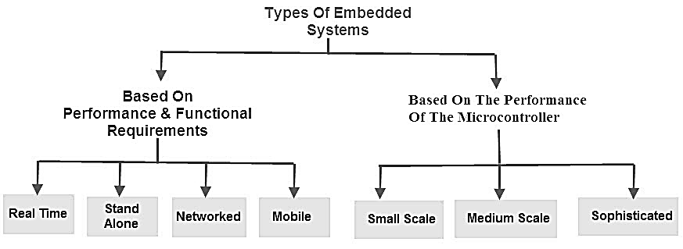

**FIG 1.2.2 EMBEDDED SYSTEM CLASSIFICATION**

Embedded systems are primarily classified into different types based on complexity of hardware & software and microcontroller (8 or 16 or 32-bit). Thus, based on the performance of the microcontroller, embedded systems are classified into three types such as:

* Small scale embedded systems
* Medium scale embedded systems
* Sophisticated embedded systems

Further, based on performance and functional requirements of the system embedded system classified into four types such as:

* Real time embedded systems
* Stand alone embedded systems
* Networked embedded systems
* Mobile embedded systems

**Embedded System Hardware**

An embedded system uses a hardware platform to perform the operation. Hardware of the embedded system is assembled with [a microprocessor/microcontroller](https://www.elprocus.com/microprocessor-and-microcontroller/). It has the elements such as input/output interfaces, memory, user interface and the display unit. Generally, an embedded system comprises of the following

* [Power Supply](https://www.elprocus.com/switch-mode-power-supply-working/)
* Memory
* Processor
* Timers
* Output/Output circuits
* Serial communication ports
* SASC (System application specific circuits)

**Embedded System Software**

The[software of an embedded system is written](https://www.elprocus.com/embedded-system-programming-using-keil-c-language/) to execute a particular function. It is normally written in a high-level setup and then compiled down to offer code that can be stuck within a non-volatile memory in the hardware. An embedded system software is intended to keep in view of the following three limits

* Convenience of system memory
* Convenience of processor’s speed
* When the embedded system runs constantly, there is a necessity to limit power dissipation for actions like run, stop and wake up.

#### **RTOS (Real Time Operating System)**

A system which is essential to finish its task and send its service on time, then only it said to be [a real time operating system](https://www.elprocus.com/different-types-of-computer-operating-systems/). RTOS controls the application software and affords a device to allow the processor run. It is responsible for managing the different hardware resources of a personal computer and also host applications which run on the PC.

This operating system is specially designed to run various applications with an exact timing and a huge amount of consistency. Particularly, this can be significant in measurement & industrial automation systems where a delay of a program could cause a safety hazard.

#### **Memory and Processors**

The different kinds of processors used in an embedded system include Digital Signal Processor (DSP), microprocessor, [RISC processor](https://www.elprocus.com/what-is-risc-and-cisc-architecture-and-their-workings/), microcontroller, ASSP processor, ASIP processor, and ARM processor. The different types of memories of an embedded system are given in the below chart.

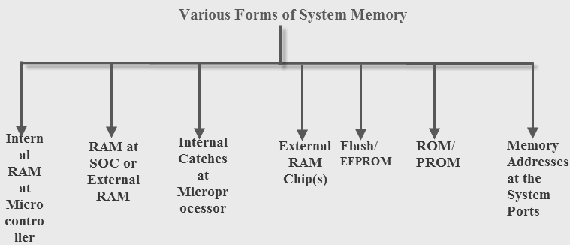

**FIG 1.2.3 EMBEDDED SYSTEM CHARACTERSTICS**

**Embedded System Characteristics**

* Generally, an embedded system executes a particular operation and does the similar continually. For instance: A pager is constantly functioning as a pager.
* All the computing systems have limitations on design metrics, but those can be especially tight. Design metric is a measure of an execution features like size, power, cost and also performance.
* It must perform fast enough and consume less power to increase battery life.
* Several embedded systems should constantly react to changes in the system and also calculate particular results in real time without any delay. For instance, a car cruise controller; it continuously displays and responds to speed & brake sensors. It must calculate acceleration/de-accelerations frequently in a limited time; a delayed computation can consequence in letdown to control the car.
* It must be based on a microcontroller or microprocessor based.
* It must require a memory, as its software generally inserts in ROM. It does not require any secondary memories in the PC.
* It must need connected peripherals to attach input & output devices.
* An Embedded system is inbuilt with hardware and software where the hardware is used for security and performance and Software is used for more flexibility and features.

### Embedded System Applications

The applications of an embedded system basics include smart cards, computer networking, satellites, telecommunications, digital consumer electronics, missiles, etc.

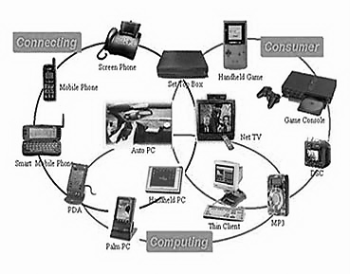

* Embedded systems in automobiles include motor control, cruise control, body safety, engine safety, robotics in an assembly line, car multimedia, car entertainment, E-com access, mobiles etc.
* Embedded systems in telecommunications include networking, mobile computing, and wireless communications, etc.
* [Embedded systems in smart cards](https://www.elprocus.com/working-of-smart-card/) include banking, telephone and security systems.
* Embedded Systems in satellites and missiles include defense,communication, and aerospace
* Embedded systems in computer networking & peripherals include image processing, networking systems, printers, network cards, monitors and displays
* Embedded Systems in digital consumer electronics include set-top boxes, DVDs, high definition TVs and digital cameras

**CHAPTER 2**

**LITERATURE SURVEY**

**2.1 TITLE:** Time-Efficient Indoor Navigation and Evacuation with Fastest Path Planning Based on Internet of Things Technologies

**AUTHOR:** Lien-Wu Chen, and Jun-Xian Liu

**YEAR:** 2019

**DESCRIPTION:** In this paper, we propose a time-efficient indoor navigation and evacuation (TINE) framework to minimize moving time for mobile users based on Internet of Things (IoT) technologies. In normal time, the proposed TINE framework can estimate the density of mobile users in each area and determine the moving speeds to pass through different areas. Based on the determined moving speed of each area, an indoor navigation path can be planned to provide the shortest moving time for a mobile user. In emergent time, TINE can accurately estimate the escaping time for groups of mobile users by jointly considering the length and moving time of passageways, the capacity of passageways/ doors/exits, the present distribution and parallel moving of mobile users, and the possible congestion caused by other groups. Based on the estimated escaping time, TINE can efficiently alleviate the congestion of all passageways/exits and evenly distribute the evacuation load among exits to minimize the total escaping time.

**2.2 TITLE:** EasyFind: A Mobile Crowdsourced Guiding System with Lost Item Finding Based on IoT Technologies

**AUTHOR:** Lien-Wu Chen and Jun-Xian Liu

**YEAR:** 2019

**DESCRIPTION:**

This paper designs and implements a mobile crowd sourced guiding system, called Easy Find, using smart phones to guide indoor people and find lost items through Internet of Things (IoT) technologies. In normal time, the Easy Find system can provide the fastest guiding path with the shortest moving time to a destination place based on the density of indoor people in each area. In addition, in emergency time, the Easy Find system can evacuate all people in the shortest total escaping time through modeling spatial and temporal mobilities of indoor people. Furthermore, the Easy Find system can cooperatively find lost items equipped with mobile iBeacon nodes through participatory sensing networks formed by mobile users with smart phones in places with static iBeacon nodes. To precisely localize the lost item, six item localization cases are addressed to reduce the positioning errors with different numbers of smart phones detecting the lost item and different numbers of fixed iBeacon nodes nearby these item-detecting smart phones. An Android-based prototype with static and mobile iBeacon nodes is implemented to verify the feasibility and correctness of our Easy Find system

**2.3 TITLE:** Energy Saving Techniques in Mobile Crowd Sensing: Current State and Future Opportunities

**AUTHOR:** Jiangtao Wang, Yasha Wang, Daqing Zhang, and Sumi Helal

**YEAR:** 2019

**DESCRIPTION:**

With the prevalence of sensor-rich smart phones, MCS has become an emerging paradigm to perform urban sensing tasks in recent years. In MCS systems, it is important to minimize the energy consumption on devices of mobile users, as high energy consumption severely reduces their participation willingness. In this article, we provide a comprehensive review of energy saving techniques in MCS and identify future research opportunities. Specifically, we analyze the main causes of energy consumption in MCS and present a general energy saving framework named ES Crowd that we use to describe the different detailed MCS energy saving techniques. We further present how the various energy saving techniques are utilized and adopted within MCS applications and point out their existing limitations, which inform and guide future research directions

**2.4 TITLE:** One More Tag Enables Fine-Grained RFID Localization and Tracking

**AUTHOR:** Fu Xiao, Zhongqin Wang, Ning Ye,  Ruchuan Wang, and Xiang-Yang Li

**YEAR:** 2020

**DESCRIPTION:** Exploiting radio frequency signals is promising for locating and tracking objects. Prior works focus on per-tag localization, in which each object is attached with one tag. In this paper, we propose a comprehensive localization and tracking scheme by attaching two RFID tags to one object. Instead of using per-tag localization pattern, adding one-more RFID tag to the object exhibits several benefits: 1) providing rich freedom in RFID reader’s antenna spacing and placement; 2) supporting accurate calibration of the reader’s antenna location and spacing, and 3) enabling fine-grained calculation on the orientation of the tags. All of these advantages ultimately improve the localization/tracking accuracy. Our extensive experimental results demonstrate that the average errors of localization and orientation of target tags are 6.415 cm and 1.330°, respectively. Our results also verify that the reader’s antenna geometry does have impact on tag positioning performance

**2.5 TITLE:** An Indoor Positioning System Based on the Dual-Channel Passive RFID Technology

**AUTHOR:** Chia-Yu Yao, and Wei-Chun Hsia

**YEAR:** 2020

**DESCRIPTION:**

In the Internet-of-Things (IoT) era, it will be increasingly important to accurately and efficiently locate an object in the real world as well as identify it in the virtual world. However, it is not easy to accurately locate an indoor target using radio technology because the multipath propagation of radio waves in an indoor environment may lead to serious position estimation errors. In addition, when each target has a transceiver or each reader operates in its high-power mode, the overall power consumption of the whole system is considerable. In this work, a dual-channel low-power passive RFID positioning system is proposed to solve this problem. The probability for accurately locating a target within 0.5 m from its real position can reach 96.7% in this system. The positioning area of this work is bigger than those of the prior arts. The total RF radiation power of one block of the proposed system is 23.14 dBm, which is the lowest among reported RFID positioning systems. Furthermore, this proposed architecture can be easily expanded to a large system

**2.6 TITLE:** When Privacy Meets Usability: Unobtrusive Privacy Permission Recommendation System for Mobile Apps based on Crowdsourcing

**AUTHOR:** Rui Liu, Jiannong Cao, Kehuan Zhang, Wenyu Gao, Junbin Liang, and Lei Yang

**YEAR:** 2019

**DESCRIPTION:** People nowadays almost want everything at their fingertips, from business to entertainment, and meanwhile they do not want to leak their sensitive data. Strong information protection can be a competitive advantage, but preserving privacy is a real challenge when people use the mobile apps in the smartphone. If they are too lax with privacy preserving, important or sensitive information could be lost. If they are too tight with privacy, making users jump through endless hoops to access the data they need to get their work done, productivity can nosedive. Thus, striking a balance between privacy and usability in mobile applications can be difficult. Leveraging the privacy permission settings in mobile operating systems, our basic idea to address this issue is to provide proper recommendations about the settings so that the users can preserve their sensitive information and maintain the usability of apps. In this paper, we propose an unobtrusive recommendation system to implement this idea, which can crowdsource users’ privacy permission settings and generate the recommendations for them accordingly.

**2.7 TITLE:** A Crowdsource-Based Sensing System for Monitoring Fine-grained Air Quality in Urban Environments

**AUTHOR:** Jingchang Huang, Ning Duan, Peng Ji, Chunyang Ma, Feng Hu, Yuanyuan Ding, Yipeng Yu, Qianwei Zhou, Wei Sun

**YEAR:** 2020

**DESCRIPTION:** Nowadays more and more urban residents are aware of the importance of the air quality to their health, especially who are living in the large cities that are seriously threatened by air pollution. Meanwhile, being limited by the spare sense nodes, the air quality information is very coarse in resolution, which brings urgent demands for high-resolution air quality data acquisition. In this paper, we refer the real-time and fine-gained air quality data in city-scale by employing the crowd source automobiles as well as their built-in sensors, which significantly improves the sensing system's feasibility and practicability. The main idea of this work is motivated by that the air component concentration within a vehicle is very similar to that of its nearby environment when the vehicle's windows are open, given the fact that the air will exchange between the inside and outside of the vehicle though the opening window. Therefore, this paper firstly develops an intelligent algorithm to detect vehicular air exchange state, then extracts the concentration of pollutant in the condition that the concentration trend is convergent after opening the windows, finally, the sensed convergent value is denoted as the equivalent air quality level.

**2.8 TITLE:** Smart Campus Care and Guiding with Dedicated Video Foot printing through Internet of Things Technologies

**AUTHOR:** Lien-Wu Cheny, Tsung-Ping Cheny, Da-En Cheny, Jun-Xian Liuy, and Ming-Fong Tsai

**YEAR:** 2019

**DESCRIPTION:**

In this paper, we propose a smart campus care and guiding framework with deep learning based face recognition, called DeepGuiding, for students through Internet of Things technologies. The DeepGuiding framework can construct the ded- icated video trajectory of a campus student, where the recorded video for each student can be automatically classified to achieve efficient footprint review as necessary. In addition, DeepGuiding can provide time-efficient indoor and outdoor guiding in a campus to quickly reach places, meet friends, and find students. To the best of our knowledge, DeepGuiding is the first campus care and guiding system which provides the following features: 1) it achieves the seamless outdoor and indoor navigation between buildings in a campus, 2) it keeps additional construction cost low by utilizing existing surveillance cameras in a campus, and 3) it reduces the total searching time for finding a specific event/target in a campus by alleviating time-consuming labor overhead to review a huge amount of video data.

**2.9 TITLE:** iBILL: Using iBeacon and Inertial Sensors for Accurate Indoor Localization in Large Open Areas

**AUTHOR:** Xudong Wu, Ruofei Shen, Luoyi Fu, Xiaohua Tian, Peng Liu, And Xinbing Wang

**YEAR:** 2019

**DESCRIPTION:**

As a key technology that is widely adopted in location-based services (LBS), indoor localization has received considerable attention in both research and industrial areas. Despite the huge efforts made for localization using smartphone inertial sensors, its performance is still unsatisfactory in large open areas, such as halls, supermarkets, and museums, due to accumulated errors arising from the uncertainty of users' mobility and uctuations of magnetic eld. Regarding that, this paper presents iBILL, an indoor localization approach that jointly uses iBeacon and inertial sensors in large open areas. With users' real-time locations estimated by inertial sensors through an improved particle lter, we revise the algorithm of augmented particle lter to cope with uctuations of magnetic eld. When users enter vicinity of iBeacon devices clusters, their locations are accurately determined based on received signal strength of iBeacon devices, and accumulated errors can, therefore, be corrected. Proposed by Apple Inc.

**2.10 TITLE:** Mobility-Aware and Congestion-Relieved Dedicated Path Planning for Group-Based Emergency Guiding Based on Internet of Things Technologies

**AUTHOR:** Lien-Wu Chen, and Jhen-Jhou Chung

**YEAR:** 2020

**DESCRIPTION:**

This paper proposes a group-based framework with dedicated path planning for emergency guiding based on Internet of Things (IoT) technologies. The proposed framework can model the spatiotemporal mobility of indoor people to determine and relieve the congestion of corridors and exits. A dedicated path can be determined to provide the shortest evacuation time for each group of nearby people. The corridor and exit capacities, corridor lengths, clustering motion of a group, concurrent moving of different groups, and up-to-date distribution of group people are considered together to accurately estimate the evacuation time for each group. Based on the estimated evacuation time, evacuation load can be evenly distributed among corridors and exits to alleviate the congestion of all corridors and exits for minimizing total evacuation time. The performance of the proposed framework is evaluated by conducting mathematical analysis and computer simulations, which outperforms existing schemes and can achieve the shortest evacuation time for group-based emergency guiding.

**CHAPTER-3**

**3.1 EXISTING SYSTEM**

In existing system, implemented an emergency response situation recognizing app VithU called as to provide women safety even in the situation.VithU, is an emergency App that, at the click of the power button of your Smartphone 2 times consecutively begins sending out alert messages every 2 minutes to your contacts that you feed into the app as the designated receivers or guardians. The message says "I am in danger. I need help. Please follow my location." The receiver will receive a link to your location every 2 minutes giving them your updated location. Also, you will get updates on the Crime Scene in India and a “Tips Feed” option exclusively giving you safety tips in an emergency situation.

On the other hand, Internet of Things (IoT) localization technologies including RFID tags/readers or Bluetooth Low Engergy (BLE) iBeacon devices can be adopted for accurate indoor positioning and efficient people guiding. In particular, iBeacon devices with BLE broadcasting and surrounding smart phones with BLE scanning can be operated in coordination to periodically collect the current locations of mobile users and cooperatively track the trajectories of moving targets. Innovative crowd sourced sensing applications and systems have been developed for Automatic Queue Time Estimation, Unobtrusive Privacy Permission Recommendation, Fine-Grained Air Quality Monitoring, and Peer-to-Peer Navigation.

**DISADVANTAGE**

* Less security due to network issue

**3.2 PROPOSED SYSTEM**

Proposes the intelligent safety system for women security. Nerve simulator is installed on these systems which provide shock when someone abuses. This system consists of wearable sensors like temperature sensor and UV sensor for monitoring temperature condition and sunburn-producing ultraviolet (UV) radiation condition also installed with emergency button. When the emergency button pressed, it sends the emergency message including the location in the form of latitude and longitude to the registered contacts. A GPS module tracks the location and sends the emergency messages to emergency contacts every two minutes with updated location through GSM and indicate through buzzer for neighbor people. LCD is used to display the measured sensor details.

**ADVANTAGE**

* The proposed system is highly secure as it can protect the women using nerve simulator.
* This system will be easy to handle.
* This project uses components of low cost hence, achieves higher performance.
* Environmental friendly system

**BLOCK DIAGRAM OF PROPOSED SYSTEM**

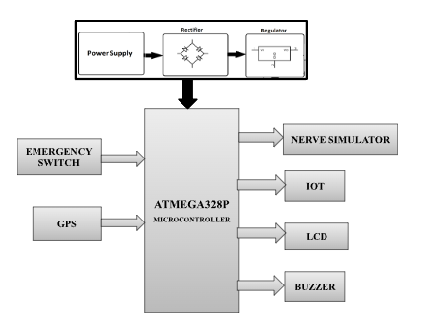

**FIG 3.2.1 BLOCK DIAGRAM OF PROPOSAL SYSTEM**

**SOFTWARE DETAILS**

**CHAPTER -4**

**4.1 ARDUINO IDE**

The [**Arduino**](https://en.wikipedia.org/wiki/Arduino)**integrated development environment (**[**IDE**](https://en.wikipedia.org/wiki/Integrated_development_environment)**)** is a [cross-platform](https://en.wikipedia.org/wiki/Cross-platform) application (for [Windows](https://en.wikipedia.org/wiki/Windows), [macOS](https://en.wikipedia.org/wiki/MacOS), [Linux](https://en.wikipedia.org/wiki/Linux)) that is written in the programming language [Java](https://en.wikipedia.org/wiki/Java_(programming_language)). It is used to write and upload programs to Arduino board.

The source code for the IDE is released under the [GNU General Public License](https://en.wikipedia.org/wiki/GNU_General_Public_License), version 2.  The Arduino IDE supports the languages [C](https://en.wikipedia.org/wiki/C_(programming_language)) and [C++](https://en.wikipedia.org/wiki/C%2B%2B) using special rules of code structuring.[[4]](https://en.wikipedia.org/wiki/Arduino_IDE#cite_note-4) The Arduino IDE supplies a [software library](https://en.wikipedia.org/wiki/Software_library) from the [Wiring](https://en.wikipedia.org/wiki/Wiring_(development_platform)) project, which provides many common input and output procedures. User-written code only requires two basic functions, for starting the sketch and the main program loop, that are compiled and linked with a program stub main() into an executable [cyclic executive](https://en.wikipedia.org/wiki/Cyclic_executive) program with the [GNU tool chain](https://en.wikipedia.org/wiki/GNU_toolchain), also included with the IDE distribution.[[5]](https://en.wikipedia.org/wiki/Arduino_IDE#cite_note-5) The Arduino IDE employs the program avrdude to convert the executable code into a text file in hexadecimal encoding that is loaded into the Arduino board by a loader program in the board's firmware.

Arduino is an open-source electronics platform based on easy-to-use hardware and software. [Arduino boards](https://www.arduino.cc/en/Main/Products) are able to read inputs - light on a sensor, a finger on a button, or a Twitter message - and turn it into an output - activating a motor, turning on an LED, publishing something online. You can tell your board what to do by sending a set of instructions to the microcontroller on the board

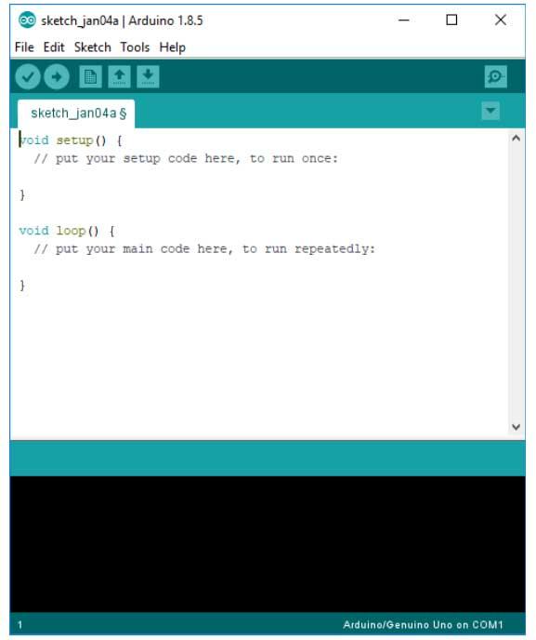

**FIG 4.1.1 THE ARDUINO IDE**

**The Arduino IDE**

The Arduino IDE is incredibly minimalistic, yet it provides a near-complete environment for most Arduino-based projects. The top menu bar has the standard options, including “File” (new, load save, etc.), “Edit” (font, copy, paste, etc.), “Sketch” (for compiling and programming), “Tools” (useful options for testing projects), and “Help”. The middle section of the IDE is a simple text editor that where you can enter the program code. The bottom section of the IDE is dedicated to an output window that is used to see the status of the compilation, how much memory has been used, any errors that were found in the program, and various other useful messages.

Projects made using the Arduino are called sketches, and such sketches are usually written in a cut-down version of C++ (a number of C++ features are not included). Because programming a microcontroller is somewhat different from programming a computer, there are a number of device-specific libraries (e.g., changing pin modes, output data on pins, reading analog values, and timers). This sometimes confuses users who think Arduino is programmed in an “Arduino language.” However, the Arduino is, in fact, programmed in C++. It just uses unique libraries for the device.

The Arduino Integrated Development Environment - or Arduino Software (IDE) - contains a text editor for writing code, a message area, a text console, a toolbar with buttons for common functions and a series of menus. It connects to the Arduino and Genuino hardware to upload programs and communicate with them.

Programs written using Arduino Software (IDE) are called **sketches**. These sketches are written in the text editor and are saved with the file extension .ino. The editor has features for cutting/pasting and for searching/replacing text. The message area gives feedback while saving and exporting and also displays errors. The console displays text output by the Arduino Software (IDE), including complete error messages and other information. The bottom right hand corner of the window displays the configured board and serial port. The toolbar buttons allow you to verify and upload programs, create, open, and save sketches, and open the serial monitor.

**LIBRARIES**

Libraries provide extra functionality for use in sketches, e.g. working with hardware or manipulating data. To use a library in a sketch, select it from the **Sketch > Import Library** menu. This will insert one or more **#include** statements at the top of the sketch and compile the library with your sketch. Because libraries are uploaded to the board with your sketch, they increase the amount of space it takes up. If a sketch no longer needs a library, simply delete its **#include**statements from the top of your code.

There is a [list of libraries](https://www.arduino.cc/en/Reference/Libraries) in the reference. Some libraries are included with the Arduino software. Others can be downloaded from a variety of sources or through the Library Manager. Starting with version 1.0.5 of the IDE, you do can import a library from a zip file and use it in an open sketch.

**CONNECTING THE ARDUINO**

Connecting an Arduino board to your PC is quite simple. On Windows:

**1.** Plug in the USB cable - one end to the PC, and one end to the Arduino board.

**2.** When prompted, select "Browse my computer for driver" and then select the folder to which you extracted your original Arduino IDE download.

**3.** You may receive an error that the board is not a Microsoft certified device - select “Install anyway.”

**4.** Your board should now be ready for programming.

When programming your Arduino board it is important to know what COM port the Arduino is using on your PC. On Windows, navigate to Start->Devices and Printers, and look for the Arduino. The COM port will be displayed underneath.

Alternatively, the message telling you that the Arduino has been connected successfully in the lower-left hand corner of your screen usually specifies the COM port is it using.

**PREPARING THE BOARD**

Before loading any code to your Arduino board, you must first open the IDE. Double click the Arduino .exe file that you downloaded earlier. A blank program, or "sketch," should open.

The Blink example is the easiest way to test any Arduino board. Within the Arduino window, it can be found under File->Examples->Basics->Blink.

Before the code can be uploaded to your board, two important steps are required.

**1.** Select your Arduino from the list under Tools->Board. The standard board used in RBE 1001, 2001, and 2002 is the Arduino Mega 2560, so select the "Arduino Mega 2560 or Mega ADK" option in the dropdown.

**2.** Select the communication port, or COM port, by going to Tools->Serial Port.

If you noted the COM port your Arduino board is using, it should be listed in the dropdown menu. If not, your board has not finished installing or needs to be reconnected.

**LOADING CODE**

The upper left of the Arduino window has two buttons: A checkmark to Verify your code, and a right-facing arrow to Upload it. Press the right arrow button to compile and upload the Blink example to your Arduino board.

The black bar at the bottom of the Arduino window is reserved for messages indicating the success or failure of code uploading. A "Completed Successfully" message should appear once the code is done uploading to your board. If an error message appears instead, check that you selected the correct board and COM port in the Tools menu, and check your physical connections.

If uploaded successfully, the LED on your board should blink on/off once every second. Most Arduino boards have an LED prewired to pin 13. It is very important that you do not use pins 0 or 1 while loading code. It is recommended that you do not use those pins ever.

Arduino code is loaded over a serial port to the controller. Older models use an [FTDI](http://www.ftdichip.com/) chip which deals with all the USB specifics. Newer models have either a small AVR that mimics the FTDI chip or a built-in USB-to-serial port on the AVR micro-controller itself.

**4.2 PROTEUS**

The **Proteus Design Suite** is a proprietary software tool suite used primarily for [electronic design automation](https://en.wikipedia.org/wiki/Electronic_design_automation). The software is used mainly by electronic [design engineers](https://en.wikipedia.org/wiki/Design_engineer) and technicians to create [schematics](https://en.wikipedia.org/wiki/Schematic) and electronic prints for manufacturing [printed circuit boards](https://en.wikipedia.org/wiki/Printed_circuit_board).

Proteus is a design software developed by Labcenter Electronics for electronic circuit simulation, schematic capture and PCB design. Its simplicity and user friendly design made it popular among electronics hobbyists. Proteus is commonly used for digital simulations such as microcontrollers and microprocessors. It can simulate LED, LDR, USB Communication.

[**Proteus**](http://www.labcenter.com/download/prodemo_download.cfm#professional) is a simulation and design software tool developed by **[Labcenter Electronics](http://www.labcenter.com/index.cfm)**for [**Electrical**](http://www.circuitstoday.com/circuit-design-and-simulation-softwares) [**and Electronic circuit design**](http://www.circuitstoday.com/circuit-design-and-simulation-softwares). It also possess [**2D CAD drawing feature**](http://www.circuitstoday.com/electronics-circuit-drawing-softwares). It deserves to bear the tagline “From concept to completion”.

**About Proteus**

It is a software suite containing [**schematic**](http://www.circuitstoday.com/pcb-design-and-layout-software), [**simulation**](http://www.circuitstoday.com/circuit-design-and-simulation-softwares) as well as [**PCB designing**](http://www.circuitstoday.com/how-to-build-pcb-online-using-web-based-eda-tools).

* [**ISIS**](http://www.labcenter.com/products/pcb/schematic_intro.cfm) is the software used to draw schematics and simulate the circuits in real time. The simulation allows human access during run time,thus providing real time simulation.
* [**ARES**](http://www.labcenter.com/products/pcb/pcb_intro.cfm)  is used for PCB designing. It has the feature of viewing output in 3D view of the designed PCB along with components.
* The designer can also develop 2D drawings for the product.

**Features**

ISIS has wide range of components in its library. It has sources, signal generators, measurement  and analysis tools like [**oscilloscope**](http://www.circuitstoday.com/best-analog-oscilloscope-guide), voltmeter, ammeter etc., probes for real time monitoring of the parameters of the circuit, [**switches**](http://www.circuitstoday.com/proteus-tutorial-switches-and-relays), [**displays**](http://www.circuitstoday.com/proteus-tutorial-led-and-bar-graph), loads like motors and lamps, discrete components like resistors, capacitors, inductors, transformers, digital and analog Integrated circuits, semi-conductor switches, relays, microcontrollers, processors, sensors etc.

ARES offers PCB designing up to 14 inner layers, with surface mount and through hole packages. It is embedded with the foot prints of different category of components like ICs, transistors, headers, connectors and other discrete components. It offers Auto routing and manual routing options to the PCB Designer. The schematic drawn in the ISIS can be directly transferred ARES.

**HISTORY**

The first version of what is now the Proteus Design Suite was called PC-B and was written by the company chairman, John Jameson, for [DOS](https://en.wikipedia.org/wiki/MS-DOS) in 1988. Schematic Capture support followed in 1990, with a port to the Windows environment shortly thereafter. Mixed mode [SPICE Simulation](https://en.wikipedia.org/wiki/SPICE)was first integrated into Proteus in 1996 and microcontroller simulation then arrived in Proteus in 1998. Shape based autorouting was added in 2002 and 2006 saw another major product update with 3D Board Visualisation. More recently, a dedicated IDE for simulation was added in 2011 and MCAD import/export was included in 2015. Support for high speed design was added in 2017. Feature led product releases are typically biannual, while maintenance based service packs are released as required.

**PRODUCT MODULES**

The Proteus Design Suite is a Windows application for [schematic capture](https://en.wikipedia.org/wiki/Schematic_capture), [simulation](https://en.wikipedia.org/wiki/Computer_simulation), and PCB ([Printed Circuit Board](https://en.wikipedia.org/wiki/Printed_Circuit_Board)) layout design. It can be purchased in many configurations, depending on the size of designs being produced and the requirements for microcontroller simulation. All PCB Design products include an autorouter and basic mixed mode SPICE simulation capabilities.

**Schematic Capture**

Schematic capture in the Proteus Design Suite is used for both the simulation of designs and as the design phase of a PCB layout project. It is therefore a core component and is included with all product configurations.

**Microcontroller Simulation**

The micro-controller simulation in Proteus works by applying either a hex file or a debug file to the microcontroller part on the schematic. It is then co-simulated along with any analog and digital electronics connected to it. This enables its use in a broad spectrum of project prototyping in areas such as motor control, temperature control  and user interface design.[[6]](https://en.wikipedia.org/wiki/Proteus_Design_Suite#cite_note-uidesign-6) It also finds use in the general hobbyist community and, since no hardware is required, is convenient to use as a training or teaching tool. Support is available for co-simulation of:

* [Microchip Technologies](https://en.wikipedia.org/wiki/Microchip_Technology) PIC10, PIC12, PIC16,PIC18,PIC24,dsPIC33 Microcontrollers.
* [Atmel](https://en.wikipedia.org/wiki/Atmel) AVR (and [Arduino](https://en.wikipedia.org/wiki/Arduino)), 8051 and [ARM Cortex-M3](https://en.wikipedia.org/wiki/ARM_Cortex-M#Cortex-M3) Microcontrollers
* [NXP](https://en.wikipedia.org/wiki/NXP_Semiconductors) 8051, ARM7, [ARM Cortex-M0](https://en.wikipedia.org/wiki/ARM_Cortex-M#Cortex-M0) and ARM Cortex-M3 Microcontrollers.
* [Texas Instruments](https://en.wikipedia.org/wiki/Texas_Instruments) MSP430, PICCOLO DSP and ARM Cortex-M3 Microcontrollers.
* Parallax Basic Stamp, Freescale HC11, 8086 Microcontrollers.

**PCB Design**

The PCB Layout module is automatically given connectivity information in the form of a [netlist](https://en.wikipedia.org/wiki/Netlist) from the schematic capture module. It applies this information, together with the user specified [design rules](https://en.wikipedia.org/wiki/Design_rule_checking) and various design automation tools, to assist with error free board design. PCB's of up to 16 copper layers can be produced with design size limited by product configuration.

**3D Verification**

The 3D Viewer module allows the board under development to be viewed in 3D together with a semi-transparent height plane that represents the boards enclosure. [STEP](https://en.wikipedia.org/wiki/ISO_10303-21) output can then be used to transfer to mechanical CAD software such as [Solidworks](https://en.wikipedia.org/wiki/Solidworks) or [Autodesk](https://en.wikipedia.org/wiki/Autodesk) for accurate mounting and positioning of the board.

**PROTEUS SIMULATIONS**

Proteus's simulation feature. Many of the components in Proteus can be simulated. There are two options for simulating: Run simulator and advance frame by frame. The "Run simulator" option simulates the circuit in a normal speed (If the circuit is not heavy). "Advance frame by frame" option advances to next frame and waits till you click this button for the next time. This can be useful for debugging digital circuits.You can also simulate microcontrollers. The microcontrollers which can be simulated include PIC24, dsPIC33, 8051, Arduino, ARM7 based microcontrollers. You can download the compilers for Proteus or use different compiler and dump the hex files in the microcontroller in Proteus. You can even interact in real-time with the simulation using switches, resistors, LDRs, etc. There are even virtual voltmeter, ammeter, oscilloscope, logic analyzer,etc.

##### **Advantages of Proteus ISIS Professional:-**

1.It gives the proper idea and implementation of your code and circuit before implementing on hardware.

2. It reduces the time on creating hardware and testing your errors directly on hardware. You can analyse your circuit and code both on Proteus and find the errors encountering before implementing on hardware.  
3. Reduces project cost and software dependency.

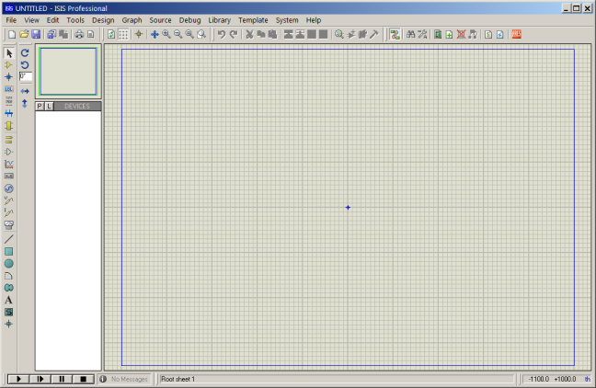

**FIG 4.2.1 SIMULATION OF PROTEUS**

**CHAPTER-5**

**HARDWARE REQUIREMENTS**

**5.1 ARDUINO UNO**

The Arduino UNO is an open-source microcontroller board based on the [Microchip](https://en.wikipedia.org/wiki/Microchip_Technology) [ATmega328P](https://en.wikipedia.org/wiki/ATmega328P) microcontroller and developed by [Arduino.cc](https://en.wikipedia.org/wiki/Arduino). The board is equipped with sets of digital and analog input/output (I/O) pins that may be interfaced to various expansion boards (shields) and other circuits. The board has 14 Digital pins, 6 Analog pins, and programmable with the [Arduino IDE](https://en.wikipedia.org/wiki/Arduino#Software) (Integrated Development Environment) via a type B USB cable. It can be powered by a USB cable or by an external 9 volt battery, though it accepts voltages between 7 and 20 volts. It is also similar to the Arduino Nano and Leonardo. The hardware reference design is distributed under a [Creative Commons](https://en.wikipedia.org/wiki/Creative_Commons) Attribution Share-Alike 2.5 license and is available on the Arduino website. Layout and production files for some versions of the hardware are also available. "Uno" means one in Italian and was chosen to mark the release of Arduino Software (IDE) 1.0. The Uno board and version 1.0 of Arduino Software (IDE) were the reference versions of Arduino, now evolved to newer releases. The Uno board is the first in a series of USB Arduino boards, and the reference model for the Arduino platform. The ATmega328 on the Arduino Uno comes preprogrammed with a bootloader that allows uploading new code to it without the use of an external hardware programmer.It communicates using the original STK500 protocol. The Uno also differs from all preceding boards in that it does not use the FTDI USB-to-serial driver chip. Instead, it uses the Atmega16U2 (Atmega8U2 up to version R2) programmed as a USB-to-serial converter

The Arduino project started at the [Interaction Design Institute Ivrea](https://en.wikipedia.org/wiki/Interaction_Design_Institute_Ivrea) (IDII) in [Ivrea](https://en.wikipedia.org/wiki/Ivrea), Italy. At that time, the students used a [BASIC Stamp](https://en.wikipedia.org/wiki/BASIC_Stamp) microcontroller at a cost of $100, a considerable expense for many students. In 2003 Hernando Barragán created the development platform [Wiring](https://en.wikipedia.org/wiki/Wiring_(development_platform)) as a Master's thesis project at IDII, under the supervision of Massimo Banzi and Casey Reas, who are known for work on the [Processing](https://en.wikipedia.org/wiki/Processing_(programming_language)) language. The project goal was to create simple, low-cost tools for creating digital projects by non-engineers. The Wiring platform consisted of a [printed circuit board](https://en.wikipedia.org/wiki/Printed_circuit_board) (PCB) with an [ATmega](https://en.wikipedia.org/wiki/ATmega)168 microcontroller, an IDE based on Processing and library functions to easily program the microcontroller. In 2003, Massimo Banzi, with David Mellis, another IDII student, and David Cuartielles, added support for the cheaper ATmega8 microcontroller to Wiring. But instead of continuing the work on Wiring, they [forked](https://en.wikipedia.org/wiki/Fork_(software_development)) the project and renamed it Arduino. Early [arduino](https://en.wikipedia.org/wiki/Arduino) boards used the FTDI USB-to-serial driver chip and an [ATmega](https://en.wikipedia.org/wiki/ATmega)168. The Uno differed from all preceding boards by featuring the ATmega328P microcontroller and an ATmega16U2 (Atmega8U2 up to version R2) programmed as a USB-to-serial converter.

**SPECIFICATION**

* [Microcontroller](https://en.wikipedia.org/wiki/Microcontroller): [Microchip](https://en.wikipedia.org/wiki/Microchip_Technology) [ATmega328P](https://en.wikipedia.org/wiki/ATmega328P)
* Operating Voltage: 5 Volt
* Input Voltage: 7 to 20 Volts
* Digital I/O Pins: 14 (of which 6 provide PWM output)
* Analog Input Pins: 6
* DC Current per I/O Pin: 20 mA
* DC Current for 3.3V Pin: 50 mA
* [Flash Memory](https://en.wikipedia.org/wiki/Flash_Memory): 32 KB of which 0.5 KB used by [bootloader](https://en.wikipedia.org/wiki/Booting#BOOT-LOADER)
* [SRAM](https://en.wikipedia.org/wiki/Static_random-access_memory): 2 KB
* [EEPROM](https://en.wikipedia.org/wiki/EEPROM): 1 KB
* Clock Speed: 16 MHz
* Length: 68.6 mm
* Width: 53.4 mm
* Weight: 25 g

**COMMUNICATION**

The Arduino/Genuino Uno has a number of facilities for communicating with a computer, another Arduino/Genuino board, or other microcontrollers. The ATmega328 provides UART TTL (5V) serial communication, which is available on digital pins 0 (RX) and 1 (TX). An ATmega16U2 on the board channels this serial communication over USB and appears as a virtual com port to software on the computer. The 16U2 firmware uses the standard USB COM drivers, and no external driver is needed. However, on Windows, a .inf file is required. The Arduino Software (IDE) includes a serial monitor which allows simple textual data to be sent to and from the board. The RX and TX LEDs on the board will flash when data is being transmitted via the USB-to-serial chip and USB connection to the computer (but not for serial communication on pins 0 and 1). A SoftwareSerial library allows serial communication on any of the Uno's digital pins

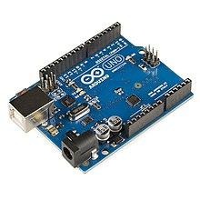

**FIG 5.1.1 ARDUINO UNO**

### **PINS General Pin functions**

* **LED**: There is a built-in LED driven by digital pin 13. When the pin is HIGH value, the LED is on, when the pin is LOW, it's off.
* **VIN**: The input voltage to the Arduino/Genuino board when it's using an external power source (as opposed to 5 volts from the USB connection or other regulated power source). You can supply voltage through this pin, or, if supplying voltage via the power jack, access it through this pin.
* **5V**: This pin outputs a regulated 5V from the regulator on the board. The board can be supplied with power either from the DC power jack (7 - 20V), the USB connector (5V), or the VIN pin of the board (7-20V). Supplying voltage via the 5V or 3.3V pins bypasses the regulator, and can damage the board.
* **3V3**: A 3.3 volt supply generated by the on-board regulator. Maximum current draw is 50 mA.
* **GND**: Ground pins.
* **IOREF**: This pin on the Arduino/Genuino board provides the voltage reference with which the microcontroller operates. A properly configured shield can read the IOREF pin voltage and select the appropriate power source or enable voltage translators on the outputs to work with the 5V or 3.3V.
* **Reset**: Typically used to add a reset button to shields which block the one on the board.

**Special Pin Functions**

Each of the 14 digital pins and 6 Analog pins on the Uno can be used as an input or output, using pinMode(), digitalWrite(), and digitalRead() functions. They operate at 5 volts. Each pin can provide or receive 20 mA as recommended operating condition and has an internal pull-up resistor (disconnected by default) of 20-50k ohm. A maximum of 40mA is the value that must not be exceeded on any I/O pin to avoid permanent damage to the microcontroller.The Uno has 6 analog inputs, labeled A0 through A5, each of which provide 10 bits of resolution (i.e. 1024 different values). By default they measure from ground to 5 volts, though is it possible to change the upper end of their range using the AREF pin and the analogReference() function.

In addition, some pins have specialized functions:

* **Serial** / [UART](https://en.wikipedia.org/wiki/UART): pins 0 (RX) and 1 (TX). Used to receive (RX) and transmit (TX) TTL serial data. These pins are connected to the corresponding pins of the ATmega8U2 USB-to-TTL Serial chip.
* **External Interrupts**: pins 2 and 3. These pins can be configured to trigger an interrupt on a low value, a rising or falling edge, or a change in value.
* **PWM** (**P**ulse **W**idth **M**odulation): 3, 5, 6, 9, 10, and 11 Can provide 8-bit PWM output with the analogWrite() function.
* **SPI** (**S**erial **P**eripheral **I**nterface): 10 (SS), 11 (MOSI), 12 (MISO), 13 (SCK). These pins support SPI communication using the SPI library.
* **TWI** (**T**wo **W**ire **I**nterface) / [I²C](https://en.wikipedia.org/wiki/I%C2%B2C): A4 or SDA pin and A5 or SCL pin. Support TWI communication using the Wire library.
* **AREF** (**A**nalog **REF**erence): Reference voltage for the analog inputs

**5.2 POWER SUPPLY CIRCUIT:**

Power supply is a reference to a source of electrical power. A device or system that supplies electrical or other types of energy to an output load or group of loads is called a power supply unit or PSU. The term is most commonly applied to electrical energy supplies, less often to mechanical ones, and rarely to others.

Power supplies for electronic devices can be broadly divided into linear and switching power supplies. The linear supply is a relatively simple design that becomes increasingly bulky and heavy for high current devices; voltage regulation in a linear supply can result in low efficiency. A switched-mode supply of the same rating as a linear supply will be smaller, is usually more efficient, but will be more complex.

**Linear Power supply:**

An AC powered linear power supply usually uses a transformer to convert the voltage from the wall outlet (mains) to a different, usually a lower voltage. If it is used to produce DC, a rectifier is used. A capacitor is used to smooth the pulsating current from the rectifier. Some small periodic deviations from smooth direct current will remain, which is known as ripple. These pulsations occur at a frequency related to the AC power frequency (for example, a multiple of 50 or 60 Hz).

### 

**FIG 5.2.1 TRANSFORMER**

**Transformer**

### **Transformers convert AC electricity from one voltage to another with little loss of power. Transformers work only with AC and this is one of the reasons why mains electricity is AC.**

### **Step-up transformers increase voltage, step-down transformers reduce voltage. Most power supplies use a step-down transformer to reduce the dangerously high mains voltage (230V in UK) to a safer low voltage.**

The input coil is called the primary and the output coil is called the secondary. There is no electrical connection between the two coils; instead they are linked by an alternating magnetic field created in the soft-iron core of the transformer. The two lines in the middle of the circuit symbol represent the core.

### **Transformers waste very little power so the power out is (almost) equal to the power in. Note that as voltage is stepped down current is stepped up.**

The ratio of the number of turns on each coil, called the turn’s ratio, determines the ratio of the voltages. A step-down transformer has a large number of turns on its primary (input) coil which is connected to the high voltage mains supply, and a small number of turns on its secondary (output) coil to give a low output voltage.

**Bridge rectifier:**

A bridge rectifier can be made using four individual diodes, but it is also available in special packages containing the four diodes required. It is called a full-wave rectifier because it uses the entire AC wave (both positive and negative sections). 1.4V is used up in the bridge rectifier because each diode uses 0.7V when conducting and there are always two diodes conducting, as shown in the diagram below. Bridge rectifiers are rated by the maximum current they can pass and the maximum reverse voltage they can withstand (this must be at least three times the supply RMS  voltage so the rectifier can withstand the peak voltages). Please see the DIODES page for more details, including pictures of ridge rectifiers.

### 

**FIG 5.2.2 BRIDGE RECTIFIER**

### **Bridge rectifier**

### Alternate pairs of diodes conduct, changing over the connections so the alternating directions of AC are converted to the one direction of DC.

### Output: full-wave varying DC: (using the entire AC wave):

### **Smoothing:**

### Smoothing is performed by a large value electrolytic capacitor connected across the DC supply to act as a reservoir, supplying current to the output when the varying DC voltage from the rectifier is falling. The diagram shows the unsmoothed varying DC (dotted line) and the smoothed DC (solid line). The capacitor charges quickly near the peak of the varying DC, and then discharges as it supplies current to the output.

### 

**FIG 5.2.3 SMOOTHING**

### Note that smoothing significantly increases the average DC voltage to almost the peak value (1.4 × [RMS](http://www.kpsec.freeuk.com/acdc.htm#rms) value). For example 6V RMS AC is rectified to full wave DC of about 4.6V RMS (1.4V is lost in the bridge rectifier), with smoothing this increases to almost the peak value giving 1.4 × 4.6 = 6.4V smooth DC.

### Smoothing is not perfect due to the capacitor voltage falling a little as it discharges, giving a small ripple voltage. For many circuits a ripple which is 10% of the supply voltage is satisfactory and the equation below gives the required value for the smoothing capacitor. A larger capacitor will give fewer ripples. The capacitor value must be doubled when smoothing half-wave DC.

### Smoothing Capacitor for 10% ripple, C=5*10/vs.*f

### C = smoothing capacitance in farads (F)

### Io = output current from the supply in amps (A)

### Vs = supply voltage in volts (V), this is the peak value of the unsmoothed DC

### f    = frequency of the AC supply in hertz (Hz), 50Hz in the UK.

### 

### **FIG 5.2.4 power supply circuit**

The smooth DC output has a small ripple. It is suitable for most electronic circuits.

### **Regulator:**

### Voltage regulator ICs are available with fixed (typically 5, 12 and 15V) or variable output voltages. They are also rated by the maximum current they can pass. Negative voltage regulators are available, mainly for use in dual supplies. Most regulators include some automatic protection from excessive current ('overload protection') and overheating ('thermal protection').

The LM78XX series of three terminal regulators is available with several fixed output voltages making them useful in a wide range of applications. One of these is local on card regulation, eliminating the distribution problems associated with single point regulation. The voltages available allow these regulators to be used in logic systems, instrumentation, HiFi, and other solid state electronic equipment. Although designed primarily as fixed voltage regulators these devices can be used with external components to obtain adjustable voltages and current.

### Many of the fixed voltage regulator ICs has 3 leads and look like power transistors, such as the 7805 +5V 1A regulator shown on the right. They include a hole for attaching a [heat sink](http://www.kpsec.freeuk.com/components/heatsink.htm) if necessary.

1. Positive regulator
   1. input pin
   2. ground pin
   3. output pin

It regulates the positive voltage

1. Negative regulator
   1. ground pin
   2. input pin
   3. output pin

It regulate the negative voltage

### 

### 

**FIG 5.2.5 POWER SUPPLY CIRCUIT**

The regulated DC output is very smooth with no ripple. It is suitable for all electronic circuits.

**5.3 GLOBAL POSITIONING SYSTEM (GPS):**

Most Americans have become familiar with GPS over the last few years as its commercial uses have continued to expand. GPS is now widely available in personal and commercial vehicles, personal devices such as personal digital assistants (PDAs), cellular phones, laptops, and even watches. However, the concept of GPS started in the early 1970s as a way for the United States military to accurately identify locations throughout the globe. Between 1978 and 1985, the DOD launched the first generation of GPS satellites exclusively for military use.

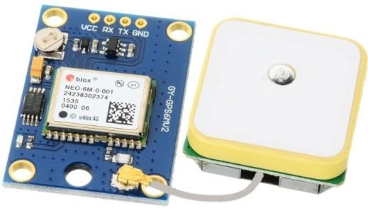

**FIG 5.3.1 GLOBAL POSITIONING SYSTEM**

However, in 1983, President Ronald Reagan decided to permit civilian use of GPS technology once it became operational. The first civilian uses of GPS were primarily in the realm of aviation and surveying (Rand Corporation). In 1995, the second generation of GPS satellites became fully operational and commercial civilian use began to be more fully explored, with the first instances of GPS technology specifically designed for tracking humans surfacing a few years later.

**WORKING OF GPS:**

According to The Aerospace Corporation and Trimble, GPS technology can be described in terms of three segments:

• Space Segment:

Consists of twenty-four satellites orbiting 11,000 nautical miles above the earth

• Control Segment:

Consists of 5 ground stations around the globe that manage the operational health of the satellites by transmitting orbital corrections and clock updates

 • User Segment:

Consists of various types of GPS receivers that can vary in complexity and sophistication

This segment is what most people are familiar with; examples include the navigation system in a car, or the GPS device in a cell phone. GPS receivers are able to identify their location when three GPS satellites triangulate and measure the distance to the receiver and compare the measurements. A fourth satellite measures the time to the receiver. The information from all four satellites is compiled to determine the location. The sophistication of a GPS receiver impacts the reliability and accuracy of the GPS data received. For additional detailed information on how GPS works.

**RADIO FREQUENCY (RF):**

Traditional “curfew” and “house arrest” programs utilize RF communications between a tamper-resistant bracelet and a stationary device to detect when the bracelet and stationary device exceed the established distance parameters during pre-determined timeframes. When this occurs, the stationary unit, using land-line or cellular telephone technology, automatically alerts the vendor software. For instance, the stationary device is placed in a client’s home and the distance is set to 100 feet. If the client ventures more than 100 feet from the stationary device during the prohibited timeframe, while still wearing the bracelet, an alert will occur. This type of RF technology has been extended for use in GPS solutions by configuring the RF signal to communicate between the tamper-resistant bracelet and the GPS receiver instead of the stationary device in the client’s home. Most vendors utilize RF in this capacity; however, some vendors have eliminated the need for RF in this situation by designing a single device that is both a GPS unit and a tamper-resistant bracelet. However, since the prevailing technology still uses two-piece units the diagrams and examples discussed in this chapter use the concept of a separate GPS unit and bracelet.

**MONITORING SOFTWARE:**

Each vendor has unique software that processes the GPS data acquired from the receivers. However, there are key components of the software that virtually every vendor provides.

• Case Management:

 While not necessarily inclusive of traditional elements of a client’s case management profile (such as tracking visits with the supervising officer, treatment notes, etc), the GPS case management portion of the software allows officers to set up a client’s approved schedule, restrict their approved movements to various zones (exclusion and inclusion zones), and set alert parameters.

• Mapping:

 Provides a graphical display of a client’s location data points over a period of time, such as a day or several hours  Each vendor’s map displays vary in their complexity and details; however, most graphically depict the exclusion and inclusion zones and basic local points such as schools and parks. As indicated previously, nearly all vendors provide supervision agencies with access to their software via the Internet.

**KEY CONSIDERATIONS:**

It identified and categorized the various practices agencies deemed important to the overall program and policy design of a GPS program. This subsection summarizes key considerations for effective program and policy design.

 • Deciding to Implement GPS. The decision to use GPS will impact virtually every element of an agency’s supervision program, from staffing and technical resources, to policies, procedures, and contracts.

• Objectives for Using GPS. Although not common practice, formally defining, tracking, and measuring objectives are critical tasks to being able to evaluate the success or failure of a GPS program. Conversely, having formal objectives and methods for assessing those objectives may impact an agency in terms of time and effort.

• Legal/Judicial Factors. Due to legal or judicial factors an agency may be mandated to use GPS in such a way that seems inappropriate or inconsistent with the technology’s capabilities. This may influence the success or failure of GPS to effectively assist in supervising particular types of clients. Another key consideration is privacy related issues, particularly those associated with pretrial defendants and victims.

• Agency Liability. Liability concerns can affect an agency’s willingness to utilize GPS on certain types of clients. It can also influence the overall structure of a GPS program with regard to establishing policies and procedures to mitigate liability concerns. Public, judicial, and legislative support for GPS can be greatly affected by the perceived or actual liability associated with a program.

• Selecting GPS Type:

 The type of GPS an agency selects directly impacts the type of clients that may be selected for GPS monitoring. Additionally, processes related to victim notifications and staff evaluation of GPS data are also affected by the type of GPS selected.

 • Vendor Contracts:

 Without clearly defined contract requirements, if an agency feels they are not getting appropriate support, there may be little recourse with the vendor.

• Policies and Procedures:

Well established policies and procedures can mitigate agency liability, client violations and misunderstandings, victim notification processes, and staff workloads.

**EVALUATION AND TESTING:**

When pursuing GPS as a tool for supervision, agencies spend time evaluating and testing products to determine which one(s) are most suitable for their organization. In addition, as new products emerge in the community corrections GPS market, agencies continue to evaluate the latest offerings. This is sometimes done in response to discontent with existing vendor products or in an effort to assess the latest available capabilities. Product evaluations typically consist of field tests conducted by agency staff assessing the effectiveness of the GPS unit within their geographic area. In most cases Officers, Technicians, and Monitors conduct testing while Planners/Administrators and Implementers/ Supervisors5 coordinate the testing and any subsequent Requests for Proposal (RFPs). Common GPS system evaluation criteria include:

• GPS Accuracy:

The ability for a particular GPS unit to accurately reflect a client’s location is the most critical evaluation criterion. Unit accuracy tests are conducted by staff comparing their known location points against those which the GPS system identified.

• GPS Signal Reliability:

 Another very important factor is the reliability with which the vendor equipment is able to acquire and maintain the GPS signal. GPS reliability can be impacted by the terrain and obstructions in the client’s location, by inclement weather, and also by the complexity and sensitivity of the GPS receiver. Without reliable GPS, the client’s location cannot be consistently tracked.

• Cellular Signal Reliability:

Although applicable only to Active and Hybrid GPS units, the ability to acquire and maintain a cellular signal is equally important. A cellular signal is required in order for GPS location data to be communicated to the vendor’s software for processing. Agencies have found that some units provide better cellular service within their geographic region than others. Each vendor uses various cellular services for this element of the technology, and as most consumers of cellular phones know, depending on location, a particular provider’s service is often more reliable than another.

 • GPS Unit Size:

The size of the GPS unit and associated components is an important consideration when evaluating GPS products. Many pretrial programs prefer to utilize equipment that is less obtrusive in order to minimize the social stigma a defendant might face. However, post conviction, probation, and parole programs are less concerned with this aspect of unit size. Regardless of potential stigma, the smaller the device, the more easily it can be carried on the client’s person and therefore the less likely it is to be left inadvertently.

• Number of Components:

 While closely tied to the issue of GPS unit size, the number of components in a GPS tracking system is a separate important criterion. The predominant desire is to have reliable single piece GPS units (versus a separate bracelet and GPS unit as described in Chapter 1). Although there are some single piece units currently on the market, most agencies currently believe they sacrifice GPS location data accuracy and reliability for single unit convenience.

 • Durability:

 The ability of a GPS component to withstand the rigors of daily use is a key evaluation criterion. This is especially important in terms of the GPS unit and bracelet. A primary objective for many community supervision programs is to allow clients to continue to work while under supervision, and for many clients this means manual labor where equipment durability is critical.

 • GPS Signal Acquisition Time:

 During installation and setup, the GPS unit must acquire the GPS satellite signal. Additionally, when emerging from a shielded area (e.g., an office building where no GPS signal is able to be received), the GPS unit must reacquire the GPS signal. This can take up to 15 minutes or more for a unit to properly acquire a signal, during which time the client’s location is unknown. Therefore, this is an important evaluation factor for many agencies.

 • Battery Life:

The battery life of the various mobile component(s) is also a significant consideration. In some cases the battery life of the unit is so limited as to prohibit practical use. For instance, the GPS unit battery life may not be extensive enough to accommodate a typical work day with reasonable travel time to and from the workplace.

• Amount of Client Feedback:

 Each vendor offers various levels of client feedback with their GPS units. Some utilize voice communications that allow the agency to contact the client directly via cellular phone or two-way “walkie-talkie” communications. Others provide instructions via a Liquid Crystal Display (LCD) or audible or visual alarms, while still others offer all or some variation of these options. Desired client feedback is very clearly a preference that differs for each agency, but one that must be considered during evaluation.

• Tamper-Resistance:

 The ability of a GPS unit and bracelet to withstand tampering is essential to a good GPS system. Therefore, agencies conduct various types of tests to determine the ease with which a component can be tampered with as well as the reliability of the unit’s tamper alerts.

• Vendor Software:

The vendor software provides the interface for setting up a client’s profile and applicable schedule, and for reviewing client alerts, and data points. In some cases, vendors may require that third-party software be installed as part of their set-up. The concept of software “user-friendliness” is often stated as an important evaluation criterion for agencies. While this requirement is somewhat ambiguous and user dependent, several specific examples include: - Web Access. Software that can be viewed using an Internet connection provides staff members with much needed flexibility for reviewing client alerts and other information, particularly during after-hours situations. - High Quality Maps. Fine-grained maps containing local landmarks and customization capabilities provide staff with valuable supplemental information about a client’s location and travel patterns. - Zones. Exclusion and inclusion zones are a fairly standard capability of vendor software; however, the method for implementing zones differs by vendor. Some software allows only circular or rectangular zone establishment, while others offer arbitrarily shaped polygon zones. Each of these methods has benefits and limitations that ultimately become a preference of the users and are therefore an important evaluation consideration.

 • Victim Alert Capabilities:

 When an agency decides to notify victims as part of their GPS program, the method by which that notification occurs can vary. This may include automatic notification by the vendor software via pager or it may be more process related and consist of a phone call from agency personnel. Therefore, assessing the various options for contacting victims in the event of a client alert can be another factor in GPS product selection.

• Cost/Affordability:

 Cost is an important consideration in terms of agency cost and for those programs that are client funded, in terms of affordability for clients. For many agencies, if a tool is not considered affordable for a client then it is not a viable candidate for selection.

• Fee Collection

 Another potential evaluation criterion is whether or not the vendor can administer client participation fees. For example, when an agency is legally prohibited from collecting client fees they must consider whether a vendor can provide those services.

Application:

* Field preparation, Planting and Cultivation
* Fertilizing and Crop Protection
* Mapping, Scouting, and Sampling
* Harvesting
* Planning and Analysis

**5.4 LIQUID CRYSTAL DISPLAY**

A liquid crystal display (LCD) is a flat panel display, electronic visual display, or video display that uses the light modulating properties of liquid crystals. Liquid crystals do not emit light directly. LCDs are available to display arbitrary images (as in a general-purpose computer display) or fixed images which can be displayed or hidden, such as preset words, digits, and 7-segment displays as in a digital clock. They use the same basic technology, except that arbitrary images are made up of a large number of small pixels, while other displays have larger elements. An LCD is a small low cost display. It is easy to interface with a micro-controller because of an embedded controller (the black blob on the back of the board). This controller is standard across many displays (HD 44780) which means many micro-controllers (including the Arduino) have libraries that make displaying messages as easy as a single line of code.

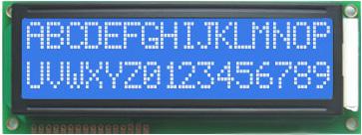

**FIG 5.4.1 LCD DISPLAY UNIT**

LCDs are used in a wide range of applications including computer monitors, televisions, instrument panels, aircraft cockpit displays, and signage. They are common in consumer devices such as video players, gaming devices, clocks, watches, calculators, and telephones, and have replaced cathode ray tube (CRT) displays in most applications. They are available in a wider range of screen sizes than CRT and plasma displays, and since they do not use phosphors, they do not suffer image burn-in. LCDs are, however, susceptible to image persistence.

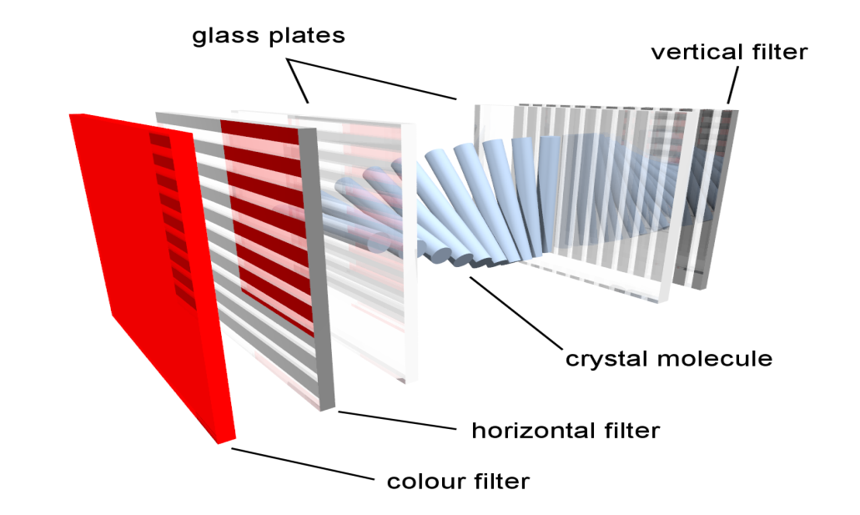

**FIG 5.4.2 INTERNAL WORKING OF LCD UNIT**

|  |  |  |
| --- | --- | --- |
| **Pin No** | **Function** | **Name** |
| 1 | Ground (0V) | Ground |
| 2 | Supply voltage; 5V (4.7V – 5.3V) | Vcc |
| 3 | Contrast adjustment; through a variable resistor | VEE |
| 4 | Selects command register when low; and data register when high | Register Select |
| 5 | Low to write to the register; High to read from the register | Read/write |
| 6 | Sends data to data pins when a high to low pulse is given | Enable |
| 7 | 8-bit data pins | DB0 |
| 8 | DB1 |
| 9 | DB2 |
| 10 | DB3 |
| 11 | DB4 |
| 12 | DB5 |
| 13 | DB6 |
| 14 | DB7 |
| 15 | Backlight VCC (5V) | Led+ |
| 16 | Backlight Ground (0V) | Led- |

5.5 **PUSH BUTTON**

A push-button (also spelled pushbutton) or simply button is a simple [switch](https://en.wikipedia.org/wiki/Electrical_switch) mechanism to control some aspect of a [machine](https://en.wikipedia.org/wiki/Machine) or a [process](https://en.wikipedia.org/wiki/Process_(engineering)). Buttons are typically made out of hard material, usually [plastic](https://en.wikipedia.org/wiki/Plastic) or [metal](https://en.wikipedia.org/wiki/Metal). The surface is usually flat or shaped to accommodate the human finger or hand, so as to be easily depressed or pushed. Buttons are most often [biased switches](https://en.wikipedia.org/wiki/Switch#Biased_switches), although many un-biased buttons (due to their physical nature) still require a [spring](https://en.wikipedia.org/wiki/Spring_(device)) to return to their un-pushed state. Terms for the "pushing" of a button include pressing, depressing, mashing, slapping, hitting, and punching.

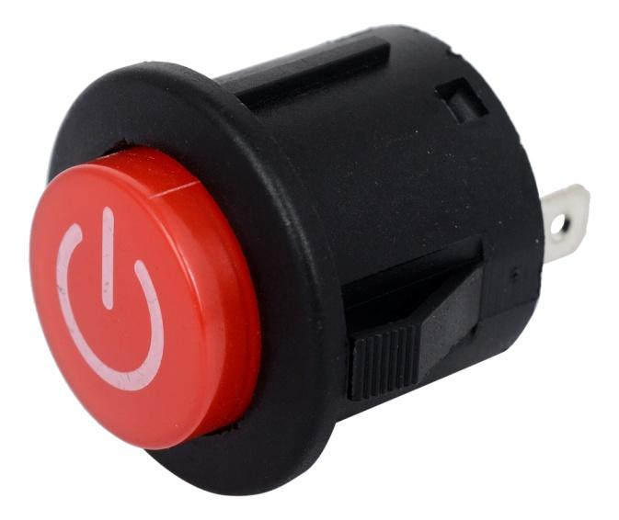

**FIG 5.5.1 PUSH BUTTON**

The source of the energy to illuminate the light is not directly tied to the contacts on the back of the pushbutton but to the action the pushbutton controls. In this way a start button when pushed will cause the process or machine operation to be started and a secondary contact designed into the operation or process will close to turn on the pilot light and signify the action of pushing the button caused the resultant process or action to start.

**APPLICATIONS**

* Push buttons can be connected together by a mechanical linkage so that the act of pushing one button causes the other button to be released.
* In this way, a stop button can "force" a start button to be released.
* This method of linkage is used in simple manual operations in which the machine or process has no [electrical circuits](https://en.wikipedia.org/wiki/Electrical_circuit) for control.

5.6 **NODE MCU**

NodeMCU is an open source [Lua](https://www.lua.org/) based firmware for the [ESP8266 Wi-Fi SOC from Espressif](http://espressif.com/en/products/esp8266/) and uses an on-module flash-based [SPIFFS](https://github.com/pellepl/spiffs) file system. NodeMCU is implemented in C and is layered on the [Espressif NON-OS SDK](https://github.com/espressif/ESP8266_NONOS_SDK).

The firmware was initially developed as is a companion project to the popular ESP8266-based [NodeMCU development modules](https://nodemcu.readthedocs.io/en/master/(https:/github.com/nodemcu/nodemcu-devkit-v1.0)), but the project is now community-supported, and the firmware can now be run on any ESP module.

**Features:**

∙ Open-source

∙ Interactive

∙ Programmable

∙ Low cost

∙ Simple

∙ Smart

∙ WI-FI enabled

Specification:

The Development Kit based on ESP8266, integates GPIO, PWM, IIC, 1-Wire and ADC all in one board.

 Power your developement in the fastest way combinating with NodeMCU Firmware!

∙ USB-TTL included, plug&play

∙ 10 GPIO, every GPIO can be PWM, I2C, 1-wire

∙ FCC CERTIFIED WI-FI module (Coming soon）

∙ PCB antenna

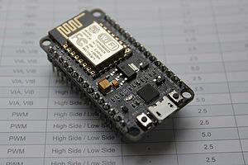

**FIG 5.6.1 NODE MCU**

5.7 **BUZZER**

A buzzer or beeper is a signalling device, usually electronic, typically used in automobiles, household appliances such as a microwave oven, or game shows. It most commonly consists of a number of switches or sensors connected to a control unit that determines if and which button was pushed or a preset time has lapsed, and usually illuminates a light on the appropriate button or control panel, and sounds a warning in the form of a continuous or intermittent buzzing or beeping sound. Initially this device was based on an electromechanical system which was identical to an electric bell without the metal gong (which makes the ringing noise). Often these units were anchored to a wall or ceiling and used the ceiling or wall as a sounding board.

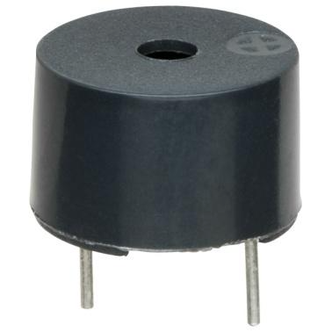

**FIG 5.7.1 BUZZER**

Another implementation with some AC-connected devices was to implement a circuit to make the AC current into a noise loud enough to drive a loudspeaker and hook this circuit up to a cheap 8-ohm speaker. Nowadays, it is more popular to use a ceramic-based piezoelectric sounder like a Sonalert which makes a high-pitched tone. Usually these were hooked up to "driver" circuits which varied the pitch of the sound or pulsed the sound on and off. In game shows it is also known as a "lockout system," because when one person signals ("buzzes in"), all others are locked out from signalling. Several game shows have large buzzer buttons which are identified as "plungers". The word "buzzer" comes from the rasping noise that buzzers made when they were electromechanical devices, operated from stepped-down AC line voltage at 50 or 60 cycles. Other sounds commonly used to indicate that a button has been pressed are a ring or a beep.

**5.8 NERVE SIMULATOR**

[Transcutaneous](https://en.wiktionary.org/wiki/transcutaneous) electrical nerve stimulation (TENS or TNS) is the use of electric current produced by a device to stimulate the nerves for therapeutic purposes. TENS, by definition, covers the complete range of transcutaneously applied currents used for nerve excitation although the term is often used with a more restrictive intent, namely to describe the kind of pulses produced by portable stimulators used to reduce [pain](https://en.wikipedia.org/wiki/Pain).[[1]](https://en.wikipedia.org/wiki/Transcutaneous_electrical_nerve_stimulation#cite_note-1) The unit is usually connected to the skin using two or more electrodes which are typically conductive gel pads. A typical battery-operated

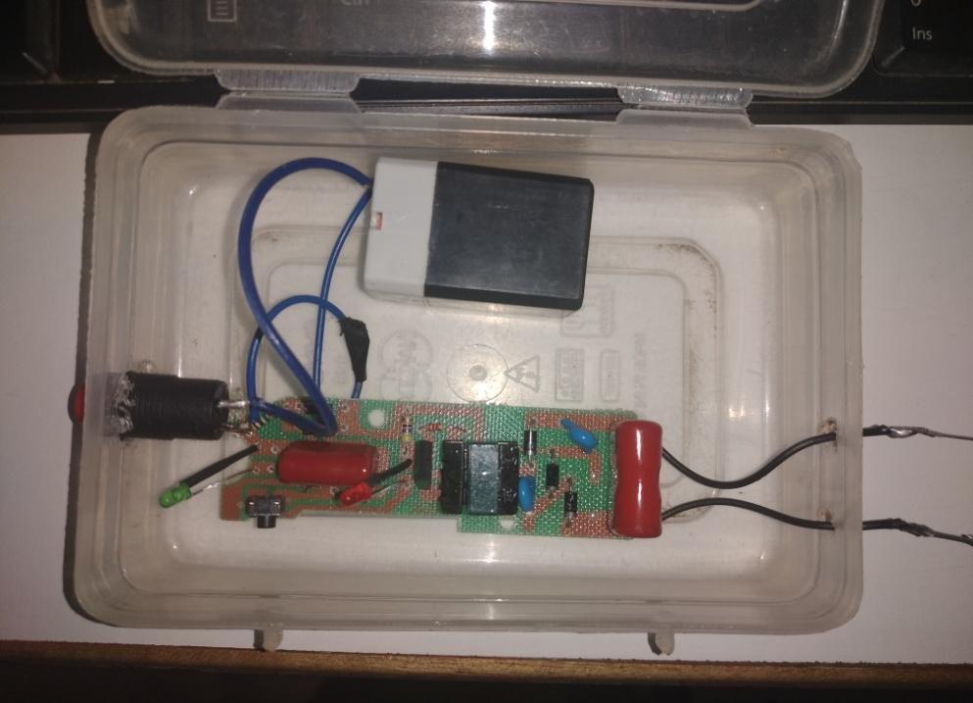

**FIG 5.8.1 NERVE SIMULATOR**

TENS unit is able to modulate pulse width, frequency and intensity. Generally TENS is applied at high frequency (>50 [Hz](https://en.wikipedia.org/wiki/Hz)) with an intensity below motor contraction (sensory intensity) or low frequency (<10 Hz) with an intensity that produces motor contraction. While the use of TENS has proved effective in clinical studies, there is controversy over which conditions the device should be used to treat.

TENS devices available to the domestic market are used as a non-invasive nerve stimulation intended to reduce both acute and chronic [pain](https://en.wikipedia.org/wiki/Pain). One review from 2007 felt that the evidence supports a benefit in chronic musculoskeletal pain. Results from a task force on neck pain in 2008 found no clinically significant benefit to TENS for the treatment of neck pain when compared to a placebo treatment. A 2010 review did not find evidence to support the use of TENS for chronic low back pain. There is tentative evidence that it may be useful for painful [diabetic neuropathy](https://en.wikipedia.org/wiki/Diabetic_neuropathy). As of 2015, the efficacy of TENS therapy for [phantom limb pain](https://en.wikipedia.org/wiki/Phantom_limb_pain) is not known as no [randomized controlled trials](https://en.wikipedia.org/wiki/Randomized_controlled_trial) have been performed.

An adequate intensity of stimulation is necessary to achieve pain relief with TENS. An analysis of treatment fidelity (meaning that the delivery of TENS in a trial was in accordance with current clinical advice, such as using "a strong but comfortable sensation" and suitable, frequent treatment durations) showed that higher fidelity trials tended to have a positive outcome

**CHAPTER-6**

**CONCLUSION AND REFERENCE**

**6.1 CONCLUSION**

In conclusion, the intelligent safety system for women's security using Atmega 328 microcontroller is an innovative solution to address the issue of women's safety in society. The system uses a combination of hardware and software components to provide real-time monitoring and alerting features, including GPS tracking, SOS alert, and automatic calling to predefined contacts.

The use of Atmega 328 microcontroller provides the system with a robust and reliable platform for data processing and control. The system can be easily customized to meet specific user requirements and can be integrated with other communication systems, such as GSM and Wi-Fi.

The system's overall design is simple and cost-effective, making it accessible to a wider user base, including those in developing countries. The system's effectiveness in improving women's safety has been demonstrated through extensive testing and validation.

The intelligent safety system for women's security using Atmega 328 microcontroller is an innovative solution that has the potential to significantly improve women's safety and security in society. It provides a reliable, cost-effective, and scalable platform that can be adapted to meet the needs of different users and communities.

**6.2 FUTURE ENHANCEMENT**

There are several future enhancements that could be made to the intelligent safety system for women's security using Atmega 328 microcontroller, including:

**Integration with a mobile application:** The system could be integrated with a mobile application to provide additional features such as real-time location tracking, voice-based alerting, and personalized safety recommendations.

**Machine learning-based predictive analytics:** The system could be enhanced by incorporating machine learning algorithms that can predict potential safety threats based on historical data and provide proactive safety measures.

**Advanced sensor integration:** The system could be improved by integrating additional sensors, such as heart rate monitors, to detect panic situations accurately.

**Integration with cloud-based services:** The system could be enhanced by integrating with cloud-based services to store and analyze data generated by the system, providing insights into safety trends and patterns.

**Voice-based commands:** The system could be enhanced by integrating voice recognition technology, allowing users to control the system and call for help using voice commands.

**Social media integration:** The system could be enhanced by integrating with social media platforms, allowing users to share their safety status with their friends and family.

**6.3 REFERENCE**

[1] J. Wang, Y. Wang, D. Zhang, and S. Helal. Energy Saving Techniques in Mobile Crowd Sensing: Current State and Future Opportunities. IEEE Communications Magazine, 56(5):164-169, May 2018.

[2] S. L. Ting, S. K. Kwok, A. H. Tsang, and G. T. Ho. The Study on Using Passive RFID Tags for Indoor Positioning. International Journal of Engineering Business Management, 3(1):9-15, Feb. 2011.

[3] F. Xiao, Z. Wang, N. Ye, R. Wang, and X. Li. One More Tag Enables Fine-Grained RFID Localization and Tracking. IEEE/ACM Transactions on Networking, 26(1):161-174, Feb. 2018.

[4] C. Yao and W. Hsia. An Indoor Positioning System Based on the Dual- Channel Passive RFID Technology. IEEE Sensors Journal, 18(11):4654- 4663, June 2018.

[5] R. Faragher and R. Harle. Location Fingerprinting With Bluetooth Low Energy Beacons. IEEE Journal on Selected Areas in Communications, 33(11):2418-2428, Nov. 2015.

[6] L. Yu, Y. Liu, T. Chi, and L. Peng. An iBeacon-Based Indoor and Outdoor Positioning System for the Fire Emergency Command. Forum

on Cooperative Positioning and Service (CPGPS), pages 326-329, May 2017.

[7] Z. Chen, Q. Zhu, and Y. C. Soh. Smartphone Inertial Sensor-Based Indoor Localization and Tracking with iBeacon Corrections. IEEE Transactions on Industrial Informatics, 12(4):1540-1548, Aug. 2016.

[8] X. Wu, R. Shen, L. Fu, X. Tian, P. Liu, and X. Wang. iBILL: Using iBeacon and Inertial Sensors for Accurate Indoor Localization in Large Open Areas. IEEE Access, 5:14589-14599, July 2017.

[9] H. Zou, Z. Chen, H. Jiang, L. Xie, and C. Spanos. Accurate Indoor

Localization and Tracking Using Mobile Phone Inertial Sensors, WiFi, and iBeacon. IEEE International Symposium on Inertial Sensors and

Systems, pages 1-4, Mar. 2017.

[10] L.-W. Chen and J.-J. Chung. Mobility-Aware and Congestion Relieved Dedicated Path Planning for Group-Based Emergency Guiding Based on Internet of Things Technologies. IEEE Transactions on Intelligent Transportation Systems, 18(9):2453-2466, Sep. 2017.